Email (Outlook)
│
▼
GetCertAgent
│
▼
ExtractDataAgent
├─ PDF → Images
├─ OCR (once)
├─ OCR Package
│
▼
Extraction Sub‑Agents (RAW)
│
▼
ExtractDataAgent (Aggregation)
│
▼
ERPrawAgent ──► ERPmrlAgent
│ │
└──────┬────────┘
▼
EvaluationAgent
│
▼
AnnotateAgent
│
▼
PrintingAgent
Introduction
Cert Agent V3 is an **agent-based automation system** designed to process laboratory certificate PDFs
used in quality and compliance workflows (herbs & spices context).

This version (**V3**) is intentionally built as a **learning and validation system**, not a decision system.
Its primary objective is to:

- Reliably extract data from **scanned paper certificates**
- Preserve extracted data **exactly as recognized**
- Enrich data using ERP reference files
- Perform **non-binding evaluations**
- Produce artifacts for **human verification**

No automatic approval, rejection, or blocking occurs in this version.

Design Philosophy

1. OCR-First by Necessity
- Certificates originate as **paper documents**
- PDFs are produced via scanning
- Embedded PDF text is unreliable or non-existent

➡️ the system treats every certificate as **image-based input**.

2. Single Source of Truth
- OCR is executed **once per page**
- All downstream agents consume the **same OCR output**
- No agent performs OCR independently

3. Raw Data Preservation
All extracted values are:
- Stored exactly as recognized
- Never corrected or normalized
- Never interpreted at extraction time

4. Separation of Concerns
Each agent:
- Has **one responsibility**
- Does **not** perform work outside its scope
- Produces explicit artifacts

Folder structure
└── Cert-Agent-V3/
├── .gitattributes
├── .gitignore
├── main.py
├── requirements.txt
├── __init__.py
├── Source_Data/
│ ├── EU Limits Data.xlsx
│ ├── pesticides_list.csv
│ ├── products_list.csv
│ └── Raw Warehouses.xlsx
├── PrintingAgent/
│ ├── printer_agent.py
│ └── __init__.py
├── GetCertAgent/
│ └── __init__.py
├── ExtractDataAgent/
│ ├── aggregator.py
│ ├── ocr_engine.py
│ ├── ocr_package.py
│ ├── pdf_to_images.py
│ ├── __init__.py
│ ├── ProductNameExtractAgent/
│ │ ├── product_name_agent.py
│ │ └── __init__.py
│ ├── LotSizeExtractAgent/
│ │ ├── lot_size_agent.py
│ │ └── __init__.py
│ ├── LotNumberExtractAgent/
│ │ ├── lot_number_agent.py
│ │ └── __init__.py
│ ├── CertNumberExtractAgent/
│ │ ├── cert_number_agent.py
│ │ └── __init__.py
│ └── AnalysisResultExtractAgent/
│ ├── analysis_result_agent.py
│ └── __init__.py
├── EvaluationAgent/
│ ├── evaluator_agent.py
│ └── __init__.py
├── ERPrawAgent/
│ ├── erp_raw_agent.py
│ └── __init__.py
├── ERPmrlAgent/
│ ├── erp_mrl_agent.py
│ └── __init__.py
├── Docs/
│ ├── Cert Agent info.docx
│ ├── Cert Agent info.pdf
│ ├── cert_agent_docs.tsx
│ ├── Cert_Agent_V3_Full_Runbook.md
│ ├── Cert_Agent_V3_Runbook_Step_by_Step.md
│ ├── File Structure.txt
│ └── ~$rt Agent info.docx
├── Config/
│ ├── config.yaml
│ ├── errors.py
│ ├── logging.yaml
│ ├── models.py
│ ├── paths.py
│ ├── utils.py
│ └── __init__.py
├── AnnotateAgent/
│ ├── annotate_agent.py
│ └── __init__.py
├── .venv/
└── .git/

GetCertAgent
- Responsibility
  - If Microsoft Outlook unavailable open Microsoft Outlook program, then connect to Microsoft Outlook
  - If Microsoft Outlook available Connect to Microsoft Outlook
  - Search Inbox for new certificate emails
  - Filter emails:
  - Sender: `fdesk@aldahlia.com`
  - Subject contains: `CERT`, `CER` (case-insensitive)
  - Download attached PDF files
- Input
  - No external input. Operates directly on Outlook inbox.
- Output
  - PDF files downloaded from matching emails.
  - Saved to Cert Agent V3/GetCertAgent/Cert_Inbox.
  - Filename: {original_pdf_name}.csv
- Does NOT
  - Parse PDF content.
  - Extract any data.
  - Make any business decision.
- Failure behavior
  - If Outlook is unavailable → wait till be available
  - If no matching emails → no action → exit without error.

ExtractDataAgent
- ExtractDataAgent is the **central spine** of Cert Agent
- Responsibility
  - Convert certificate PDFs into images (one image per page)
  - Perform OCR once per page.
  - Produce a shared OCR package for downstream extraction agents.
  - Coordinate extraction by invoking 5 extraction sub-agents.
  - Collect raw outputs from all sub-agents.
  - Assemble a final single CSV file with all extracted raw data per lot per certificate (for explicit multi-lot cases).
  - 5 sub agents
    - CertNumberExtractAgent
    - ProductNameExtractAgent
    - LotNumberExtractAgent
    - LotSizeExtractAgent
    - AnalysisResultExtractAgent
- Internal Processing
  - PDF → Images
    - One image per page
    - Preserve page order
  - OCR per page
    - Text lines
    - Line order
    - (Optional) bounding boxes
  - Build OCR Package
    - Example:
Cert Agent V3\ExtractDataAgent\Cert_To_PNG_OCR/
├── {original_pdf_name}_page_1.png
├── {original_pdf_name}_page_1.tsv
├── {original_pdf_name}_page_1_ocr.json
├── {original_pdf_name}_page_2.png
├── {original_pdf_name}_page_1.tsv
├── {original_pdf_name}_page_2_ocr.json
- Shared OCR Package (Contract)
  - Each {original_pdf_name}_page_X_ocr.json contains:
- page_number
  - lines[] : text - line_index - (optional) bbox
  - That only contract is the one that all the sub-agents see.
- Sub-Agents Invocation
  - ExtractDataAgent:
- Invokes each extraction sub-agent
- Provides OCR Package only
- Collects their CSV outputs
  - All OCR is performed only by ExtractDataAgent. Sub-agents consume OCR Package only.
- Aggregation Logic
  - Collect scalar outputs:
- cert_number_raw
- product_name_raw
- lot_number_raw
- lot_size_raw
  - Collect table output:
- analyte_raw and result_raw
  - Multi-lot handling:
- Explicit (A/B, A-B) → one CSV per lot
- Implicit (A/2) → single CSV
- Input
  - PDF files stored in Cert Agent V3/GetCertAgent/Cert_Inbox
  - CSV files which stored in
    - Cert Agent V3/ CertNumberExtractAgent/Cert_Number_CSVs
    - Cert Agent V3/ ProductNameExtractAgent/Product_Name_CSVs
    - Cert Agent V3/ LotNumberExtractAgent/Lot_Number_CSVs
    - Cert Agent V3/ LotSizeExtractAgent/Lot_Size_CSVs
    - Cert Agent V3/AnalysisResultExtractAgent/Analysis_Result_CSVs
- Output
  - CSV file
    - One CSV per lot per certificate (for explicit multi-lot cases).
    - Save it in Cert Agent V3/ ExtractDataAgent/ Cert_Data_CSVs
    - Filename: {original_pdf_name}_{lot_number}_Data.csv
    - If file exists → overwrite without warning
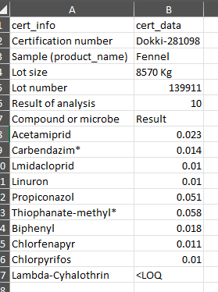
    - CSV look like:
Get that from
CertNumberExtractAgent
Get that from
ProductNameExtractAgent
Get that from
LotSizeExtractAgent
Get that from
LotNumberExtractAgent
Get that from
AnalysisResultExtractAgent
Count of pesticides

  - OCR Package
    - Save it in Cert Agent V3\ExtractDataAgent\Cert_To_PNG_OCR/
    - PNG Filename: {original_pdf_name}_page_X.png
    - JSON Filename: {original_pdf_name}_page_X.json
    - If file exists → overwrite without warning
- Does NOT
  - Parse any data meaning
  - Access ERP
  - Perform extraction logic itself.
  - Interpret values.
  - Decide business meaning.
  - Access ERP or MRL files.
- Failure behavior
  - If OCR fails on a page → page marked unreadable, pipeline continues.
  - If sub-agent output missing → corresponding fields left empty.
  - No blocking, no decisions.

CertNumberExtractAgent
- Responsibility
  - Extract raw Certificate number text from OCR package
- Input
  - OCR Package from ExtractDataAgent stored in Cert Agent V3\ExtractDataAgent\Cert_To_PNG_OCR/
- Logic
  - Search across all pages
  - Anchor-based:
    - “Certificate Number”
    - “Cert No”
  - Take nearest valid value
- Output
  - CSV file, CSV with one row and two column: cert_info, cert_number_raw
  - Save it in Cert Agent V3/CertNumberExtractAgent/Cert_Number_CSVs
  - Filename: {original_pdf_name}_CertNumber.csv
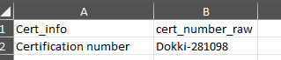
  - CSV look like:

- Does NOT
  - Parse certificate number meaning
  - Access ERP
  - OCR
  - Validate format
  - Guess missing values

- Failure behavior
  - If certificate number not found → cert_number_raw is empty.

ProductNameExtractAgent
- Responsibility
  - Extract raw Product name text from OCR Package
- Input
  - OCR Package from ExtractDataAgent stored in Cert Agent V3\ExtractDataAgent\Cert_To_PNG_OCR/
  - Cert Agent V3/Source_Data/ products_list.csv (that file include all product names list “if needed to get right name when extract”)
- Logic
  - Search across all pages
  - Anchor-based:
    - “Product name”
    - “Sample”
  - Prefer header section
- Output
  - CSV file, CSV with one row and two column: cert_info, product_name_raw
  - Save it in Cert Agent V3/ProductNameExtractAgent/Product_Name_CSVs
  - Filename: {original_pdf_name}_ProductName.csv
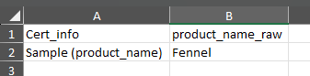
  - CSV look like:

- Does NOT
  - Parse product name meaning
  - Access ERP
- Failure behavior
  - If product name not found → product_name_raw is empty.

LotNumberExtractAgent
- Responsibility
  - Extract raw Lot number text from OCR Package
- Input
  - OCR Package from ExtractDataAgent stored in Cert Agent V3\ExtractDataAgent\Cert_To_PNG_OCR/
- Logic
  - Search across all pages
  - Anchor-based:
    - “Lot number”
  - Return full raw string:
    - 139912/139913
    - 139865/2
- Output
  - CSV file, CSV with one row and two column: cert_info, lot_number_raw
  - Save it in Cert Agent V3/LotNumberExtractAgent/Lot_Number_CSVs
  - Filename: {original_pdf_name}_LotNumber.csv
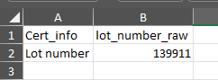
  - CSV look like:

- Does NOT
  - Parse lot number meaning
  - Access ERP
- Failure behavior
  - If product name not found → lot_number_raw is empty.

LotSizeExtractAgent
- Responsibility
  - Extract raw Lot Size text from OCR package
- Input
  - OCR Package from ExtractDataAgent stored in Cert Agent V3\ExtractDataAgent\Cert_To_PNG_OCR/
- Logic
  - Search across all pages
  - Anchor-based:
    - “Lot size”
  - Capture value + unit as raw text
- Output
  - CSV file, CSV with one row and one column: cert_info, lot_size_raw
  - Save it in Cert Agent V3/ LotSizeExtractAgent/Lot_Size_CSVs
  - Filename: {original_pdf_name}_LotSize.csv
  - CSV look like:
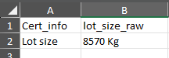

- Does NOT
  - Parse lot size meaning
  - Access ERP
- Failure behavior
  - If product name not found → lot_size_raw is empty.

AnalysisResultExtractAgent
- Responsibility
  - Extract raw analysis result rows from OCR package, preserving text exactly as recognized.
- Input
  - OCR Package from ExtractDataAgent stored in Cert Agent V3\ExtractDataAgent\Cert_To_PNG_OCR/
  - Pages ordered and indexed
  - Cert Agent V3/Source_Data/ pesticides_list.csv (that file include all pesticides names list “if needed to get right name when extract”)
- Logic
  - Search across all pages
  - Detect table start:
    - “Results of analysis”
    - “Compound or microbe”
  - Continue across pages until section ends
  - Each row:
    - analyte_raw
    - result_raw
- Output
  - CSV file, CSV file with multiple rows and columns: analyte_raw, result_raw
  - Save in Cert Agent V3/AnalysisResultExtractAgent/Analysis_Result_CSVs
  - Filename: {original_pdf_name}_AnalysisResult.csv
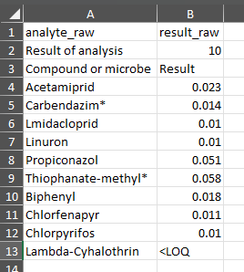
  - CSV look like:

- Does NOT
  - Parse analysis result meaning
  - Access ERP
  - Convert results to numbers
  - Compare with MRL
  - Merge duplicate analytes
  - Decide pass/fail
  - Correct OCR mistakes
  - Drop suspicious rows
هو Recorder مش Analyzer.
- Failure behavior
  - If product name not found → result_analysis_raw is empty.
  - Table anchor not found➜ Output CSV empty
  - OCR page unreadable➜ Skip page, log page_number
  - Partial table extracted➜ Output partial data (no blocking)

ERPrawAgent
- Responsibility
  - Use data extracted from certificates (lot number) to search in ERPraw file (Raw Warehouses.xlsx) to get internal lot number and supplier name.
  - IN ERPraw file
    - Lot number in first column
    - Internal lot number in third column
    - Supplier name in forth column
    - Supplier name always written in Arabic
- Input
  - CSVs files stored in Cert Agent V3/LotNumberExtractAgent/Lot_Number_CSVs
  - ERPraw file : Cert Agent V3/Source_Data/ Raw Warehouses.xlsx
  - ERPraw file contain multi sheets must search in all of them
- Output
  - CSV file
  - Same CSV with add new four column: cert_info, lot_number_raw ,internal_lot_number , supplier_name
  - Save it in Cert Agent V3/ ERPrawAgent/ ERPraw_CSVs
  - Filename: {original_pdf_name}_{lot_number}_ERPraw.csv
  - CSV look like:
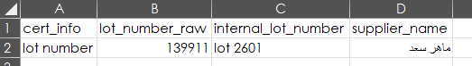
اسم المورد
موجود فى ملف
ERPraw
فى العمود رقم 4
و الا سم مكتوب بالعربى
رقم اللوط الداخلى
موجود فى ملف
ERPraw
فى العمود رقم 3
رقم اللوط اللى فى الشهادة
موجود فى ملف
ERPraw
فى العمود رقم 1

- Does NOT
  - Decide supplier correctness
  - Merge multiple suppliers
  - Apply business rules
- Failure behavior
  - If lot number not found in ERPraw file → leave internal_lot_number and supplier_name empty

ERPmrlAgent
- Responsibility
  - Use data extracted from certificates (product name and result of analysis) to search in ERPmrl file (EU Limits Data.xlsx) to get limits of pesticides which found in certificate.
- Input
  - CSVs files stored in Cert Agent V3/ ExtractDataAgent/ Cert_Data_CSVs
  - ERPmrl file : Cert Agent V3/Source_Data/ EU Limits Data.xlsx
  - ERPraw file contain multi sheets must search in all of them
- Output
  - CSV file
  - Same CSV with add new one column: eu_mrl
  - Save it in Cert Agent V3/ ERPmrlAgent/ ERPmrl_CSVs
  - Filename: {original_pdf_name}_{lot_number}_ERPmrl.csv
  - CSV look like:
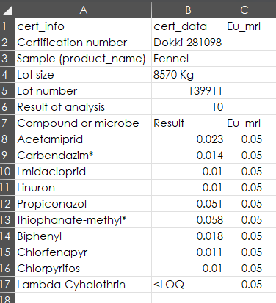
Get those limits
From ERPmrl file
According to product

- Does NOT
  - Parse eu limits meaning
- Failure behavior
  - If product not found in ERPmrl file → print product not found in ERPmrl file
  - If pesticide not found in ERPmrl file → print that pesticide not found in ERPmrl file

EvaluationAgent
- Responsibility
  - Evaluate extracted laboratory results against ERP reference data.
  - Perform numeric and availability comparisons only.
  - Generate an evaluation report for manual review.
  - Do NOT make any final decision.
- Input
  - CSV files per (certificate × lot) from:
    - ERPrawAgent get supplier_name and internal_lot_number from: Cert Agent V3/ERPrawAgent/ERPraw_CSVs
    - ERPmrlAgent get eu_mrl from: Cert Agent V3/ERPmrlAgent/ERPmrl_CSVs
    - ExtractDataAgent get lot_number_raw and product_name_raw and analyte_raw and result_raw from: Cert Agent V3/ExtractDataAgent/Cert_Data_CSVs
- Output
  - One Evaluation CSV file per (certificate × lot).
  - Saved in: Cert Agent V3/EvaluationAgent/Evaluation_CSVs
  - Filename: {original_pdf_name}_{lot_number}_Evaluation.csv
  - Evaluation CSV Columns
    - cert_info,
    - lot_number,
    - supplier_name,
    - internal_lot_number,
    - analyte,
    - result_raw,
    - eu_mrl,
    - evaluation_flag,
    - evaluation_notes
  - evaluation_flag values (informational only):
    - OK
    - EXCEEDED
    - MRL_NOT_FOUND
    - RESULT_NOT_NUMERIC
    - LOT_NOT_FOUND_IN_ERP
- Decision Rules
  - ERP lookup
If internal_lot_number is empty ➜ evaluation_flag = LOT_NOT_FOUND_IN_ERP
  - Result format
If result_raw is not numeric (e.g. LOQ, ND) ➜ evaluation_flag = RESULT_NOT_NUMERIC
  - MRL availability
If eu_mrl is empty for any analyte ➜ evaluation_flag = MRL_NOT_FOUND
  - Numeric comparison
If result_raw > eu_mrl ➜ evaluation_flag = EXCEEDED
Else ➜ evaluation_flag = OK
- Does NOT
  - Decide ACCEPT / REJECT / REVIEW.
  - Block printing or annotation.
  - Modify certificate PDFs.
  - Interpret business or regulatory meaning.
  - Auto-correct or guess values.
- Failure behavior
  - If any required input CSV is missing ➜ Generate evaluation CSV with evaluation_flag = INCOMPLETE_DATA
  - If unexpected error occurs ➜ Generate evaluation CSV with error note, pipeline continues.

AnnotateAgent
- Responsibility
  - Annotate certificate PDFs with supplier name and internal lot number(s)
- Input
  - PDF files stored in Cert Agent V3/GetCertAgent/Cert_Inbox
  - CSV files stored in Cert Agent V3/ ERPrawAgent/ ERPraw_CSVs
- Output
  - PDF file.
  - Save it in Cert Agent V3/ AnnotateAgent/Annotated_PDFs
  - Filename: {original_pdf_name}_{lot_number}_Annotated.csv
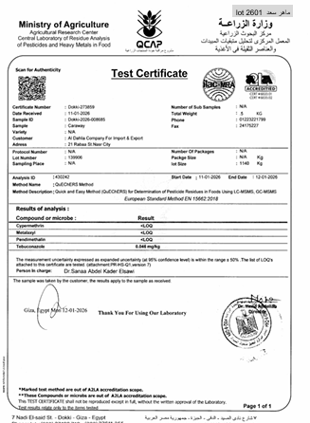
  - Annotated PDF look like:

- Does NOT
  - Decide which supplier to use
  - Handle multi-supplier conflict
- Failure behavior
  - .

PrintingAgent
- Responsibility
  - Connect to local Printer
  - Printer name “HP Neverstop Laser 100x”
  - Print certificate annotated pdfs
- Input
  - PDF files stored in Cert Agent V3/ AnnotateAgent/Annotated_PDFs
- Output
  - PDF files
  - Save files in" Cert Agent V3\Printed_Cert
  - Filename: {original_pdf_name}_{lot_number}_Printed.csv
  - If the printer not available
    - Save Save files in" Cert Agent V3\PrintingAgent\Wating_To_Print_Cert

- Does NOT
  - Parse any data meaning
  - Access ERP
- Failure behavior
  - If printer not found be calm and Retry until printer is connected (manual intervention).

CertAgent
- Responsibility
  - Manage all other agents
- Input
  - .
- Output
  - .

- Does NOT
  - Contain business logic
  - Perform data extraction or comparison
- Failure behavior
  - If a critical agent fails (GetCertAgent / ExtractDataAgent) → stop pipeline
  - Otherwise, continue and mark missing outputs.

Raw Certificate Pdf Explain

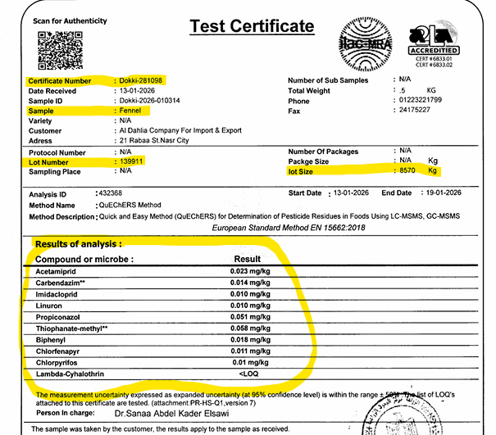
Lot number
Product
Name
Lot
weight
Result of analysis
Certification Number

All Certs in the same format
الشهادات دى اصلها ورق و تعمل بسكانر و تحفظ ك pdf
الشهادات دى ممكن تبقى على صفحتين لو كمية المبيدات كتير
Just different in number of pesticides
- Certification number
لازم تبقى بالشكل ده Dokki - xxxxxx
- Product name) Sample)
اسم المنتج
فى ملف CSV موجود عندى فى اسامى المنتاجات كلها لو محتاجينه اسمه products_list.csv
- lot Size
ده علطول رقم بعديه Kg
- Lot number
بيبقى فيها اشكال كتير
الاختلافات فى رقم اللوط ممكن تبقى يالاشكال دى
1 - Lot Number : 139385
ده معناه انه لوط واحد لمورد واحد
مثال المورد سعيد حمدى لوط 2601
2- Lot Number : 139912/139913
ده معناه انه لوطين بس لمورد واحد و منتج واحد (لوطين متحللين مع بعض)
مثال : المورد ماهر سعد لوط 2601 و 2602
او اتنين موردين بس منتج واحد
مثال : المورد سعيد حمدى لوط 2601 و المورد ماهر سعد لوط 2601
3- Lot Number : 139865/2
ده معناه انه لوطين بس لمورد واحد و منتج واحد
رقم اللوط هنا هو واحد بس اللى هو 139865 و ده هيبقى مثلا ماهر سعد لوط 2605
بس لما هنكتب على الشهادة هنكتب ماهر سعد لوط 2605 +1
4- Lot Number : 139865/3
ده معناه انه 3 لوطات بس لمورد واحد ومنتج واحد
رقم اللوط هنا هو واحد بس اللى هو 139865 و ده هيبقى مثلا ماهر سعد لوط 2605
بس لما هنكتب على الشهادة هنكتب ماهر سعد لوط 2605 +2

5- Lot Number : 139865/5
ده معناه انه خمس لوطات بس لمورد واحد ومنتج واحد
رقم اللوط هنا هو واحد بس اللى هو 139865 و ده هيبقى مثلا ماهر سعد لوط 2605
بس لما هنكتب على الشهادة هنكتب ماهر سعد لوط 2605 +4

6- Lot Number : 139679-139680
ده معناه انه لوطين بس لمورد واحد و منتج واحد (لوطين متحللين مع بعض)
مثال : المورد ماهر سعد لوط 2601 و 2602
او اتنين موردين بس منتج واحد
مثال : المورد سعيد حمدى لوط 2601 و المورد ماهر سعد لوط 2601

7- Lot Number : SFP228
ده معناه انه لوط واحد
8- Lot Number : 163-31-03-39-2394
ده معناه انه لوط واحد
9- Lot Number : DH956-TX/2025
ده معناه انه لوط واحد
10- Lot Number : 91191
ده معناه انه لوط واحد

الشهادة اللى فيها رقمين لو دول لوطين فى شهادة واحدة
يعنى لما نبحث فى ملف الاكسيل هنبحث على رقمين
مثال
Lot number : 139912/139913 او Lot number : 139912-139913
هندور على 139912 المفروض نلاقى مثلا سعيد حمدى لوط 2601
هندور على 139913 المفروض نلاقى مثلا سعيد حمدى لوط 2602
لما نكتب على الشهادة هنكتب
سعيد حمدى لوط 2601 - لوط 2602

ممكن يبقى موردين مختلفيين
هندور على 139912 المفروض نلاقى مثلا سعيد حمدى لوط 2601
هندور على 139913 المفروض نلاقى مثلا ماهر سعد لوط 2611
لما نكتب على الشهادة هنكتب
سعيد حمدى لوط 2601 - ماهر سعد لوط 2611

ممكن يبقى موردين مختلفيين او مورد واحد بس فيه واحد منهم مش موجود فى الاكسيل
هندور على 139912 المفروض نلاقى مثلا سعيد حمدى لوط 2601
هندور على 139913 مش موجود فى الاكسيل
لما نكتب على الشهادة هنكتب
سعيد حمدى لوط 2601 - 139913 N/A

- Results of analysis
فى ملف CSV موجود عندى فى اسامى المبيدات كلها لو محتاجينه اسمه pesticides_list.csv

- أصل الشهادات وطبيعتها
كل الشهادات أصلها ورقي وتم عمل:
Scan
حفظ كـ PDF
مفيش PDF حقيقي Text-based يعتمد عليه
أي Text موجود داخل الـ PDF:
يا إمّا OCR سابق
يا إمّا fragment ومش reliable

- عدد الصفحات
- ممكن تكون صفحة واحدة
- ممكن تكون صفحتين (بسبب عدد المبيدات)
- عدد الصفحات مرتبط بعدد صفوف جدول التحاليل فقط
- الهيدر دايمًا في الصفحة الأولى
- جدول التحاليل ممكن يبدأ في صفحة ويكمّل في الصفحة اللي بعدها بدون عنوان جديد وده أخطر جزء.

- كل الشهادة العام (ثابت في كل الملفات)
- كل الشهادات ليها نفس البنية المنطقية حتى لو التنسيق اختلف:
  - A) Header (أعلى الصفحة الأولى)
    - فيه دايمًا:
    - Certificate Number
    - Product Name
    - Lot Number
    - Lot Size
  - والنقطة المهمة:
    - القيم دي مش في جدول
    - مكتوبة كـ Label : Value
    - أحيانًا النص قريب
    - أحيانًا OCR يلزقهم

  - B) جدول Results of Analysis (جسم الشهادة)
    - ده أهم جزء.
    - خصائص الجدول:
- عمود اسم المبيد (Compound / Microbe)
- عمود النتيجة (Result)
- ممكن يكون فيه:
  - Units
  - Method
    - شكل النتائج:
- أرقام عشرية (0.023)
- أو <LOQ
- أو LOQ
- أحيانًا OCR يلخبط < أو O/0

  - C) Footer (أسفل آخر صفحة)
- توقيع
- ختم
- تاريخ
- اسم المعمل
ولا حاجة فيهم مهمة للاستخراج.

- تحليل أرقام اللوت (Lot Number) من الشهادات
كل حالات اللوت اللي موثقها:
  - Single lot
- 139385
- 139798
- 139800
✔ straightforward

  - Explicit multi-lot
- 139912-139913
ده:
- لوطين
- لازم search مرتين في ERP
- وAnnotation يكتبهم بالشكل اللي إنت موثقه

  - Implicit multi-lot
- 139880/2
ده:
- رقم واحد ظاهر
- implicit count
- لا ينقسم
- annotation فيه +1
✔ موجود فعليًا في الشهادات

- أسماء المنتجات (Product Name)
- كلها واضحة
- كلمة واحدة غالبًا:
  - Fennel
  - Basil
  - Peppermint
  - Marjoram
لكن:
- OCR ممكن:
  - يزود space
  - يلخبط حرف
- فـ ProductNameExtractAgent:
  - لازم يبقى tolerant
  - بس يطلع raw

- جدول التحاليل – أخطر استنتاج
- مفيش شهادة واحدة:
  - الجدول فيها aligned perfectly
- بعض الصفوف:
  - اسم المبيد في سطر
  - والنتيجة تحته
- في الصفحات التانية:
  - مفيش Header للجدول
  - بس صفوف مباشرة
👉 ده يثبت إن:
AnalysisResultExtractAgent لازم:
- يعرف يبدأ
- يعرف يكمل
- وما يعتمدش على شكل أعمدة ثابت

